

**Asset Practice Questions: Mathematics**

1. There are some plants planted in a circle in Ila's garden. Each plant has some flowers on it. For example Plant 1 has 2 flowers on it.

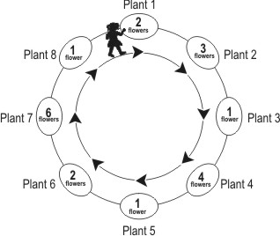

Ila starts from plant 1 and goes around the circle in the direction shown by the arrows. As she goes along, she keeps plucking all the flowers from the plants. After plucking flowers from which plant, will she have 11 flowers?

A. Plant 4

B. Plant 5

C. Plant 6

D. Plant 7

2. Arti, Deepa and Garima were given sheets having some small dots and some big dots. They had to draw a shape using 4 of those dots. For each small dot in their shape, they would get 1 point and for each big dot in their shape, they would get 10 points. For example, for the shape shown here the total points will be 10+1+1+1=13, because there is 1 big dot and 3 small dots.



If Garima draws a shape using 4 of the dots, what is the highest score she can get?

A. 4

B. 10

C. 40

D. 44

3. Tia had 20 marbles. She distributed her 20 marbles between Mita and Zarina so that each of them got

10 marbles.

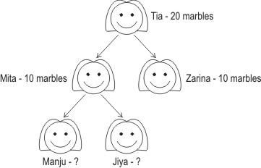

Mita also distributes her 10 marbles in the same way between Manju and Jiya. How many marbles would Manju get?

A. 20

B. 15

C. 5

D. 0

4. A shop sells eggs in four types of boxes - boxes containing 6, 12, 15 and 18 eggs (as shown in the figure).

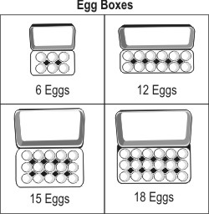

Khushi buys 2 boxes of '15 eggs' and Diana buys 5 boxes of '6 eggs'. Who has more eggs?

A. Khushi

B. Diana

C. Both of them have the same number of eggs.

D. (We cannot say because the type of boxes are different.)

5. Lily and her friends go to an amusement park. They find this chart pasted at the counter. It tells them how much they have to pay for different rides.

|  |  |
| --- | --- |
| Ride | Amount for one person |
| Merry-Go-Round | Rs 15 |
| Toy rain | Rs 10 |
| Jumping Jack | Rs 20 |
| Chiti Chiti Bang | Rs 10 |

Lily, Gargi and Gomti want to enjoy a ride on the 'Jumping Jack'. What is the total amount they have to pay?

A. Rs 20

B. Rs 30

C. Rs 45

D. Rs 60

6. The dots in the boxes form a pattern.

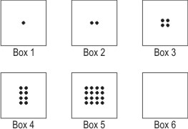

How many dots will be there in Box 6?

A. 32

B. 24

C. 20

D. 16

7. Devi, Puja and Priyam are running in a park. They start from the same place. But they take different paths to reach the ice-cream stall at the opposite corner.

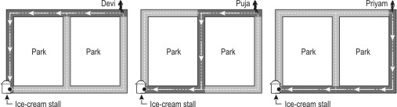

Who takes the LONGEST path? A. Devi

B. Puja

C. Priyam

D. All their paths are equally long.

8. Naimish has put some coins in rows. He has arranged 8 coins in each row. He has covered some of the coins with a paper as shown. How many coins are there totally?



A. 8

B. 12

C. 23

D. 32

9. Vinod had 85 marbles in a jar. He had another jar which was empty.

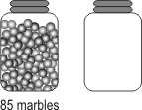

He took 15 marbles from the jar and put them into the empty jar.



How many marbles does he have totally , in both the jars?

A. 70

B. 85

C. 100

D. (We can say only after counting.)

10. Look at the numbers shown below.

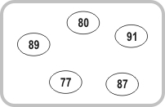

Which of these can be said about the given numbers?

A. They are all greater than 79.

B. They are all less than 90.

C. They are all between 70 and 90.

D. They are all between 75 and 95.

11. Which group below has more girls than boys?

A.  B. 

C.  D. 

12. Which of these will be equal to 97?

A. 7 ones + 9 tens

B. 7 tens + 9 ones

C. 9 tens + 7

D. 9 ones + 7 ones